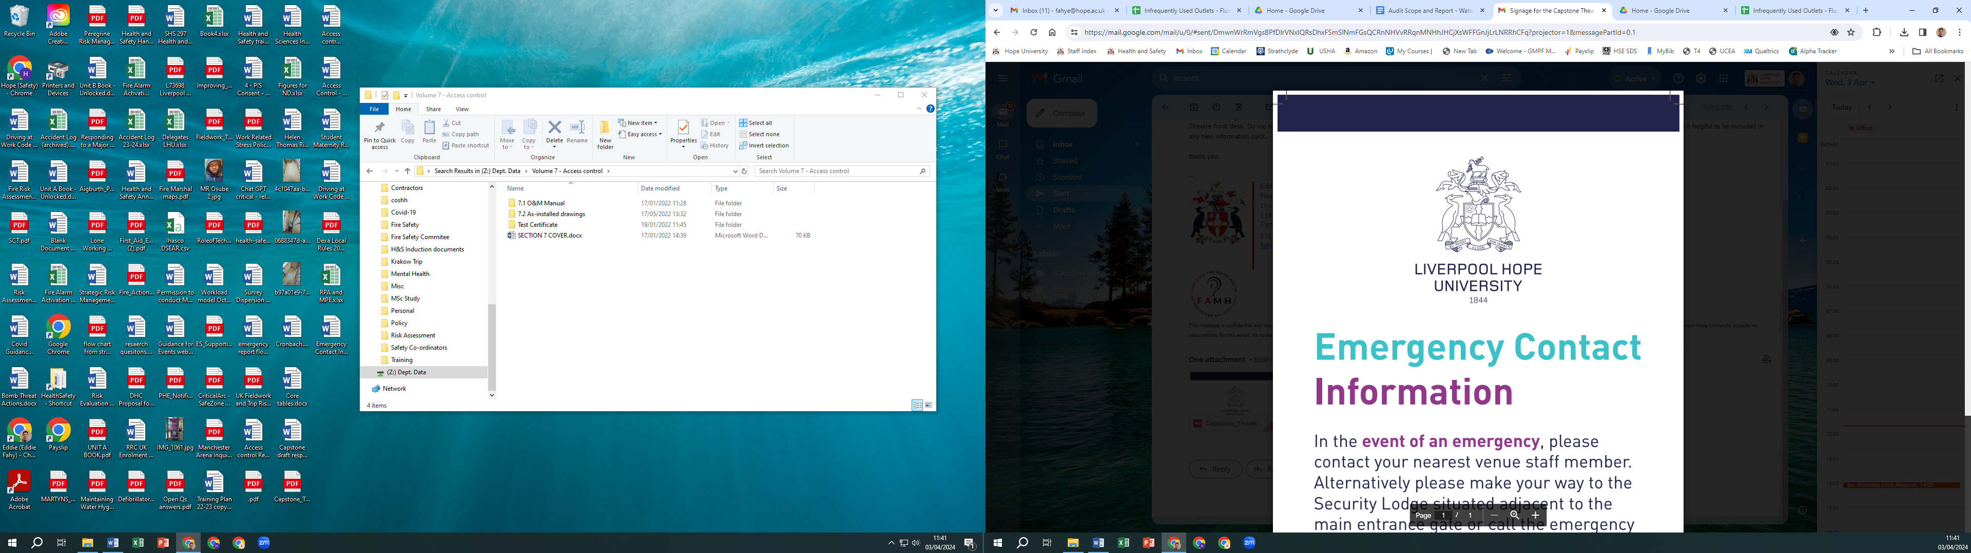

**Snow & Ice**

**Clearing Policy**

**Document Control**

|  |  |
| --- | --- |
| Responsibility for Policy: | Director of Estates |
| Approved by and date: | Draft 1 to SMT March 2023 |
| Frequency of Review: | Annually |
| Next Review date: | January 2026 |
| Related Policies: |  |
| Minor Revisions: |  |

Estates Department

Overview

The winter months from November to March present a number of problems relating to the environment caused by snow and ice. During the winter months Estates will do their utmost to create safe pedestrian routes and has a prioritised maintenance procedure in place for snow clearance and gritting. The decision whether to grit footpaths is made with reference to the rolling five-day weather forecast. Gritting will take place: a) on the day when snow has fallen and stayed, b) on the day if temperatures are below freezing and ice has formed, c) if there is visible ground frost, surfaces are checked, and if found slippery, gritted, or d) if frost or snow is predicted during the evening.

**The presence of snow and ice does present health and safety risks as the potential to slip increases significantly. Staff and students are advised to take appropriate care when walking on treated and untreated paths.**

Service Provision

The Estates team will maintain all University building entrances and footpaths within the Campus. Priority is given to the removal of snow from building entrances and the gritting of paths:

**Priority one:**

* Hope Park Campus – main footpaths leading to and from HCA, FML, Gateway, AJB, Student Accommodation, the library and steps leading from the car parks
* Creative Campus – main footpaths to and from the Cornerstone, Capstone and Hopkins Hall
* Aigburth Park Campus – main footpaths to and from the Trinity building to halls of residence entrances.

**Priority two:**

* Hope Park – remaining pathways
* Creative Campus – pathways within Angel Fields
* Aigburth Park Campus – remaining pathways.

When it snows, the response is adapted to meet the circumstances and decisions are made dependant on the conditions at the time.

1. Regularly check stores of salt and ensure that there are sufficient salt stocks for the prevailing weather conditions, providing supplies are available nationally
2. Car Parks/Access Road – areas of high risk are gritted such as sloped access to the rear sports hall and upper library car park; and where the road bends
3. Out of core University hours we will make every attempt to keep the main footpaths gritted, especially around the halls of residence.

Estates are responsible for keeping accurate records in relation to the winter clearance of snow and gritting, including:

* Prevailing weather conditions
* Details of pre or reactive gritting undertaken
* Complaints from staff, students or visitors
* Records of any accidents.

Response Times

We aim to meet the identified target responses provided below:

To start salting and clearing building entrances from 8.30 am Monday to Friday, or earlier if heavy frost is predicted. It is desirable that snow clearance and gritting to be completed by midday, however, any times set for completion is dependent on what can be ‘reasonably’ achieved with available resources and the amount of frost and snow. Paths and roads will continue to be treated with salt throughout the day while the temperature remains below freezing.

Exceptional Circumstances

Priority will be given to removing the snow from building entrances and priority one footpaths. However, there is no guarantee of safe pedestrian routes as winter conditions are so variable:

* It takes time for the salt to become effective
* In severe cold weather (below -8°C) salt cannot prevent the roads and footpaths from freezing
* Gritting cannot be carried out while it is raining as the grit would be washed away i.e., when frost or snow follows rain
* When temperatures fall rapidly, as we will not have had chance to grit the pathways
* When the snow is heavy and incessant it would make the exercise pointless.

In the Event of Exceptionally Severe Weather Conditions

* The University will endeavour to keep the building entrances and priority one footpaths clear
* If the weather conditions deteriorate and building entrances, priority one footpaths and external roads cannot be kept clear then the Senior Management Team will take appropriate action according to the severity of the weather
* The Senior Managers will then advise whether the campus may need to be closed for normal operations
* If the closure of campus is decided then this will be communicated using the usual procedures.

Off Campus Responsibilities

Snow clearance and the gritting of roads and pavements outside the campus is not the responsibility of the University. Staff and students are advised to take care when walking on these treated or untreated roads or pavements.

Security Lodge Phone Numbers

Please remember that you can contact your security lodge on the numbers below;

Hope Park Security Lodge on 0151 291 3520

Creative Campus Security Lodge on 0151 291 3939

Aigburth Park Security Lodge on 0151 291 3095.

Emergency Phone Numbers

In an emergency, please contact your lodge on the numbers below:

Hope Park Emergency no. – 0151 291 3800

Creative Campus Emergency no. – 0151 292 3700

Aigburth Park Emergency no. – 0151 291 3095.